**Leet Code Problem : 367 valid square problem O(log n)**

**Problem Statement**

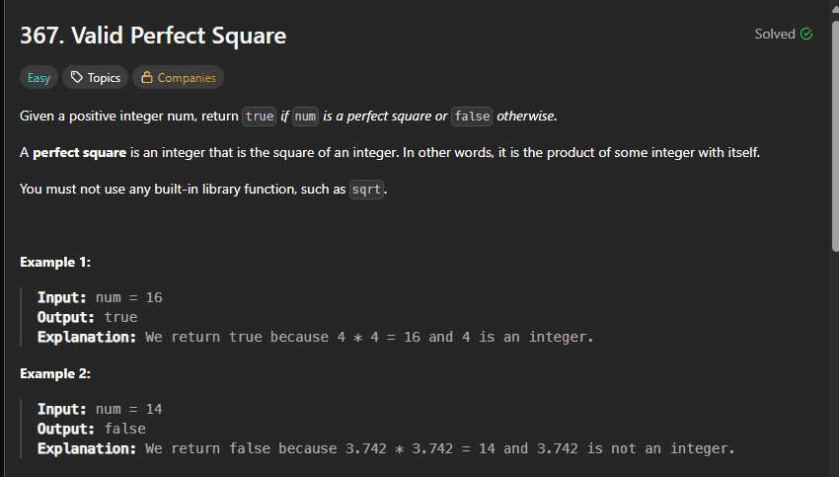**Generated Results**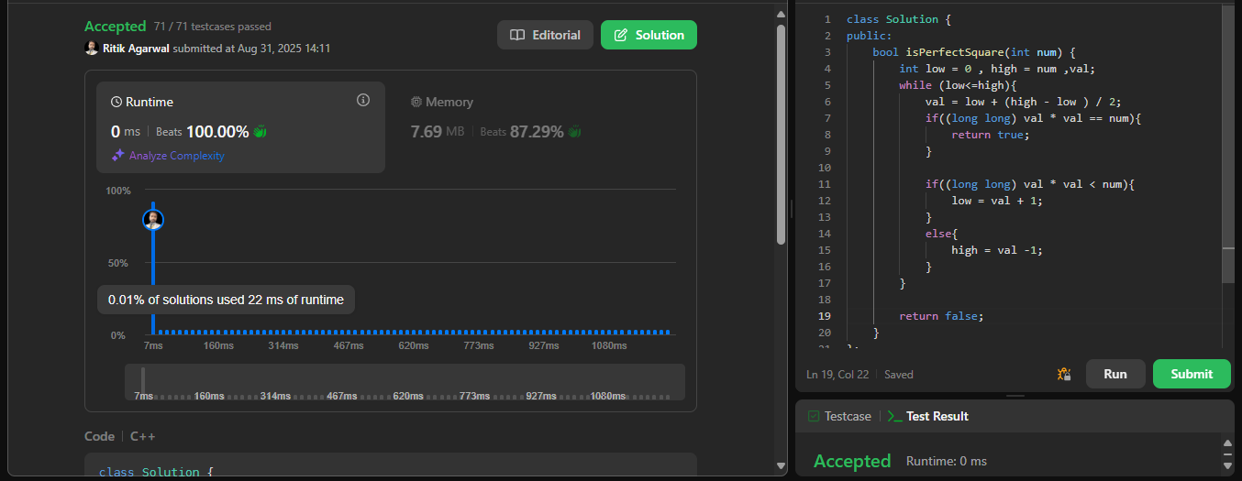

**Code Snippet**

class Solution {

public:

    bool isPerfectSquare(int num) {

        int low = 0 , high = num ,val;

        while (low<=high){

            val = low + (high - low ) / 2;

            if((long long) val * val == num){

                return true;

            }

            if((long long) val * val < num){

                low = val + 1;

            }

            else{

                high = val -1;

            }

        }

        return false;

    }

};

**My learnings:**

1 . Nothing much , already in previous question I found optimised solution, so same thing applied here and it worked